Woodford Valley Church of England Primary Academy - Home/School Agreement

A child’s education begins at home and as such we value the partnership of school and parents. Woodford Valley Primary School’s mission is “Towards Christian Life, Learning and Love” and the school’s 6 values underpin all that we do. This home/school agreement outlines the aims and values of our school, your responsibilities and what the school expects of its pupils.
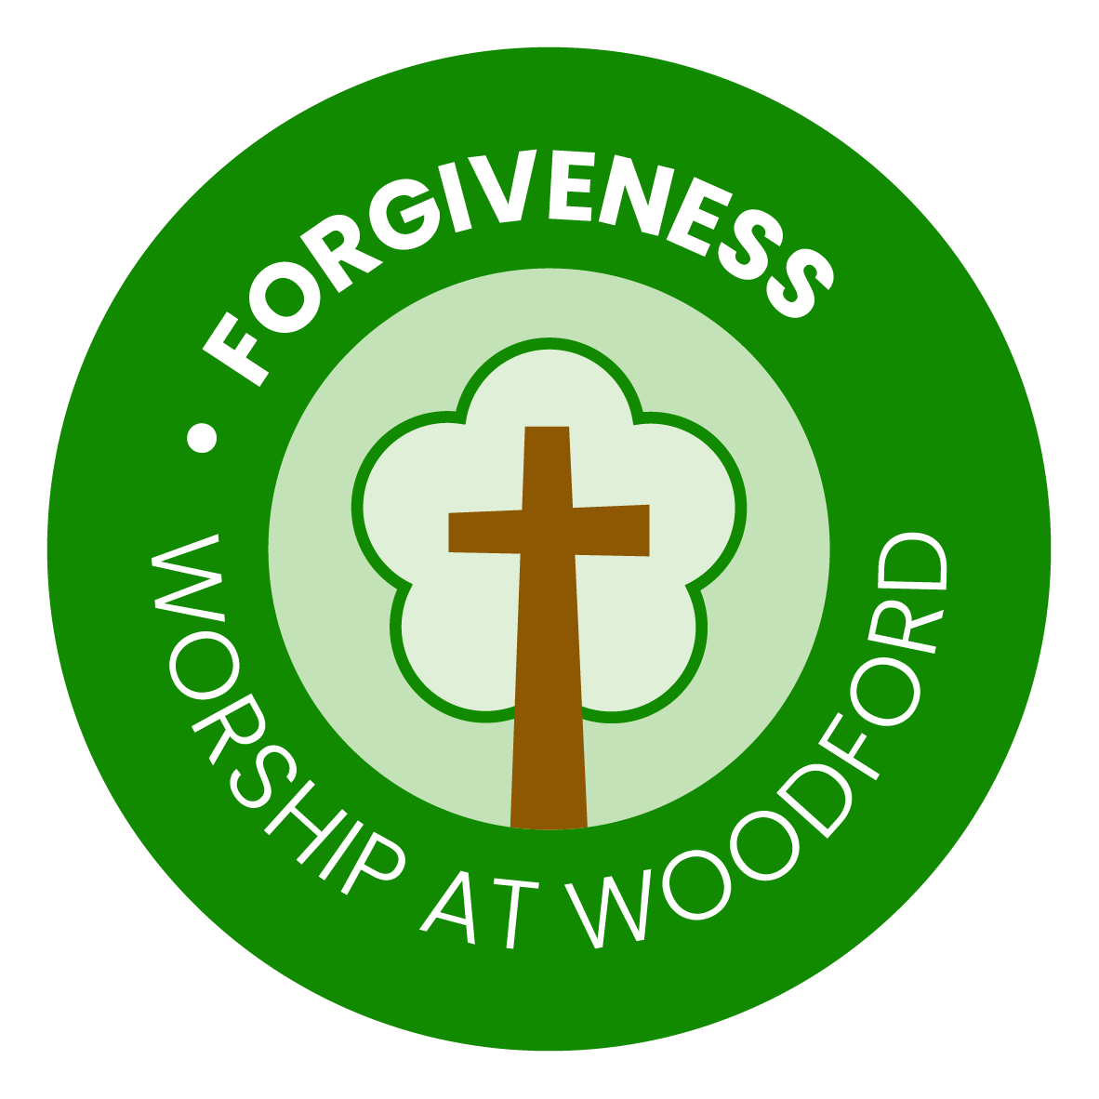
School | Parents | Child
To help each child grow in Christian Life, Learning and Love, the school will demonstrate our values by:  Kindness  - Building strong, caring relationships within a Christian community.  - Valuing every member of the school.  - Welcoming parents and the wider community.  Creativity  - Planning lessons to meet the needs of all children.  Courage  - Supporting every child to reach their potential.  Trust  - Communicating regularly with parents about progress and concerns.  - Ensuring fairness and a safe, happy environment for all.  Forgiveness  - Encouraging good behaviour and hard work through praise and example.  Hopefulness  - Teaching pupils to stay safe online at school and at home.  Signed (school) ___________________________ | To help my child grow in Christian Life, Learning and Love, I (we) will demonstrate the school values by:  Kindness  - Giving praise and encouragement.  - Supporting good behaviour and participation in school activities.  Creativity  - Helping with homework and encouraging neat, thoughtful work.  - Listening to their child read regularly.  Courage  - Informing the school about any concerns.  - Attending Parent’s Evenings when possible.  Trust  - Ensuring children attend school punctually, dressed appropriately, with correct equipment.  - Keeping contact details updated and labelling all items of uniform.  Forgiveness  - Being patient and supportive when children make mistakes or face challenges.  Hopefulness  - Providing healthy lunches and snacks.  - Helping children follow e-safety rules.  - Avoiding taking family holidays during term time.  Signed (parents) ______________________________ | As I grow in Christian Life, Learning, and Love, I will show our values by:  Kindness  - Being kind, considerate, and polite to everyone in the school.  - Helping and supporting others in school activities, including sport and music.  Creativity  - Trying my best and working neatly in all tasks.  - Thinking of new ideas and trying different ways to learn.  Courage  - Speaking up and telling a teacher if there is a problem.  - Taking part in school activities, even when it feels challenging.  Trust  - Following the school rules, including e-safety guidelines.  - Taking care of school equipment and looking after the school environment.  Forgiveness  - Being patient and understanding with others when mistakes happen.  - Saying sorry and making things right if I hurt someone or make a mistake.  Hopefulness  - Bringing everything I need to school (reading folders, homework, PE kit).  - Believing in myself and always trying my best.  Signed (child) _______________________________  Class ______________________________________

