Upper Woodford
Dear All,
Welcome back, we hope you all had a lovely Easter break.
We are now into our last two terms of the school year and so far this year we have had a great time. The children were all amazing on our trip to Hampton Court last term, we were very proud of their behaviour and their keenness to carry out Tudor jobs!
Life in Upper Woodford will continue to be busy over the next two terms.
Our class planning for this term is on the class webpage, we are focusing on the topic of the Caribbean, in particular, St Lucia.
PE days are Mondays with Ben and Thursdays with Jo. Please make sure the children have their kit as it is important they participate in their PE sessions. It would be great if they can come changed for PE on a Thursday morning.
The children are very lucky to be taking part in Forest School during the summer terms with Mr Reavill on a Thursday afternoon- more details will follow.
On a Friday, the class will be taking part in drumming sessions.
Homework
The children will continue to receive spellings to take home on a Monday, they need to fill the sheet in at home and return it the following Monday, they will then be tested on their spellings.
Literacy homework will be set on a Monday and will be handed in on Wednesdays. Maths homework will be set on a Wednesday and then be completed by Monday.
Reading books
The children should have a reading book in school at all times, this can be from home or from within school. The children can record when they have read in their reading diary. We will be carrying out whole class guided reading sessions weekly where the focus will be on comprehension of a text.
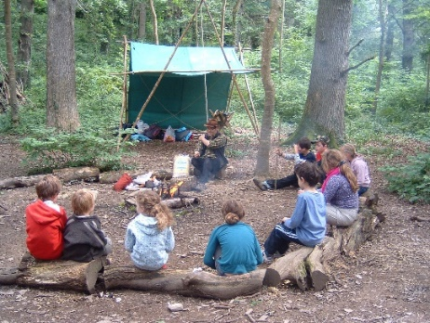
Please come and see us if you have any worries or concerns.
The Upper Woodford Team

